Step 1:

Login credential(invalid)

Invalid Username,Invalid Password

Expected:error

Actual:error

Status:fail

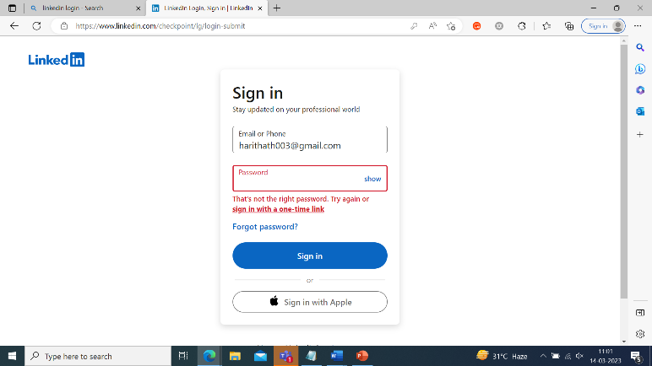

Step2:

Login Credential:Invalid

Invalid username,

Valid password

Expected:error

Actual:Error

Status:Fail

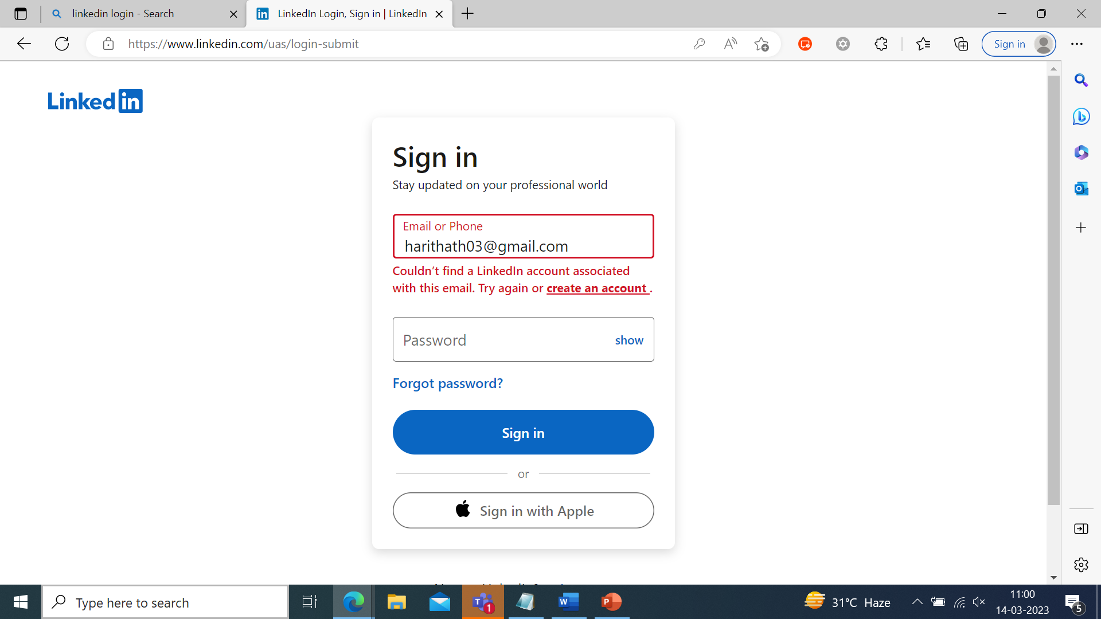

Step 3:

Login Credential(Invalid)

Invalid username

Invalid password

Expected:error

Actual:error

Status:Fail



Step 4:

Login credential(valid)

Valid Username

Valid password

Expected:pass

Actual:Pass

Status:pass

